Assignment no.06

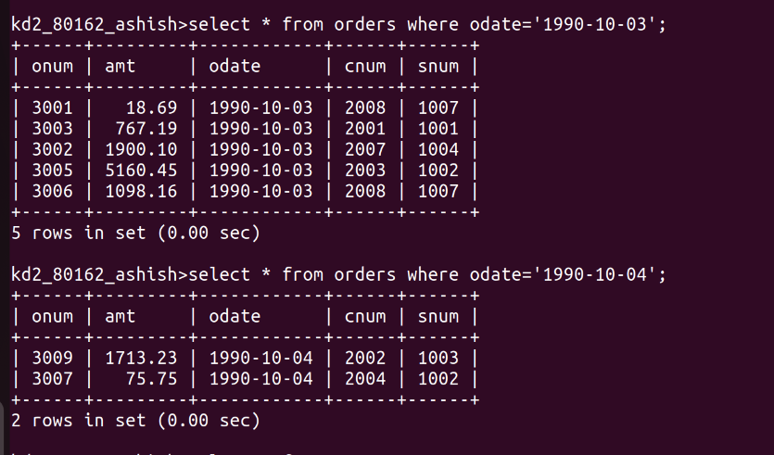
Q.01)Write two different qureies that would produce all orders taken on October 3rd or 4th,1990.

Q.02)Write a query that selects all of the customers serviced by peel or motika.
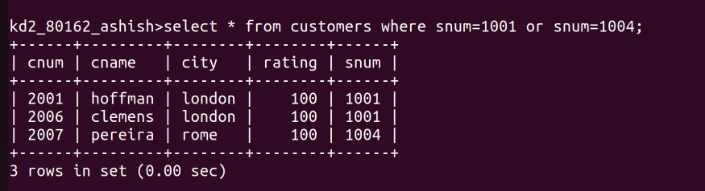
Q.3)Write a query that will produce all the customers whose names begin with a letter from ‘a’ to ‘g’

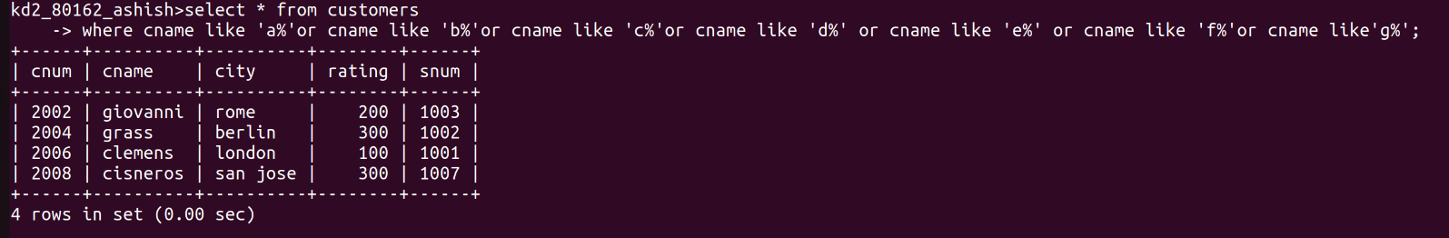
Q.4)Write a query that selects all customers whose names begins with the letter ‘c’

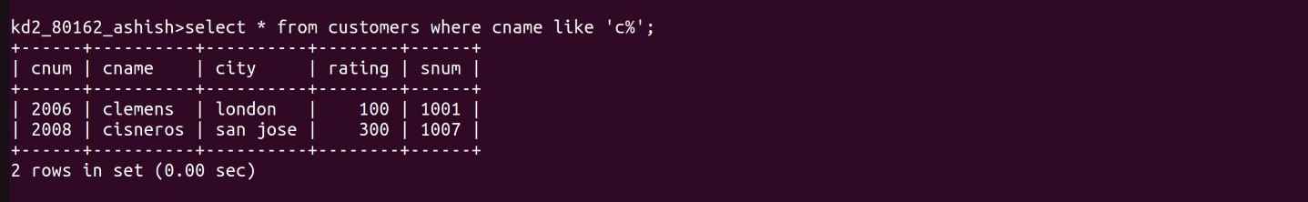
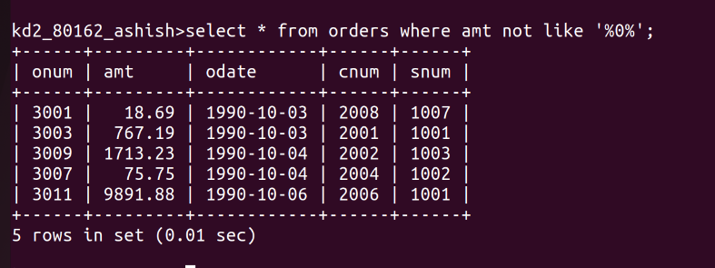
Q.5)Write a query that selects all orders except those with zeroes or NULLs in the amt field.

